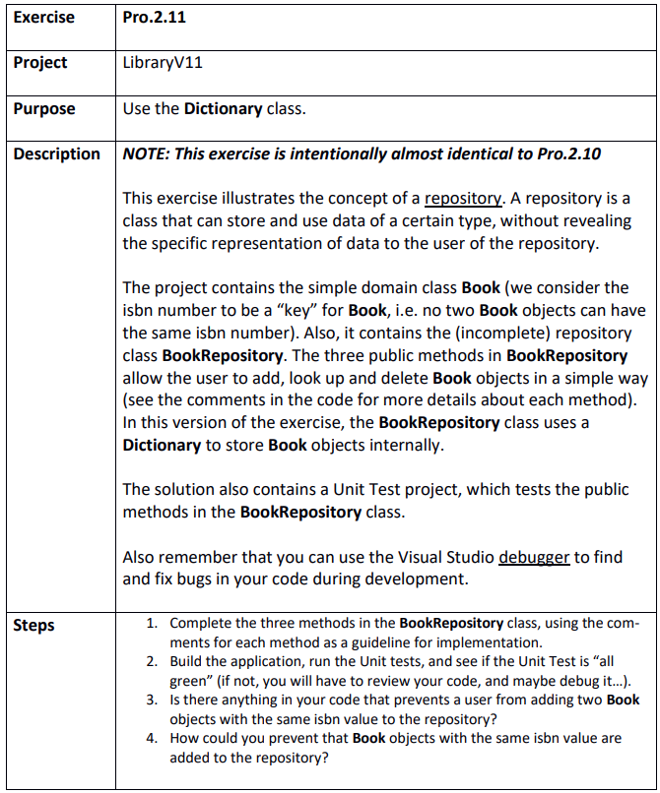

Step 1
LibraryV11.sln
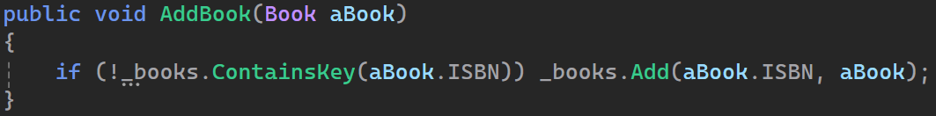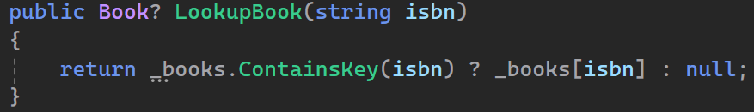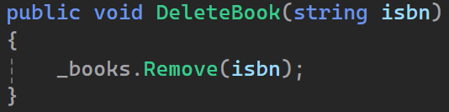

Step 2
Test success

Step 3
Yes the dictionary prevents that by throwing an error
To prevent this error we do nothing if it already exists

Step 4
Like I already do

